MRU / SOE/ CSE/ R-22 / MR22-1CS0141/2023-2024

**Assignment Test- 2**

**Subject : DAA/ MR22-1CS0141**

**Submission Dates : 10-10-2023 to 14-10-2023**

1. Write the Union and Find algorithms with suitable example and analyze its complexity.

2. Calculate the articulation points for the following graph and draw the bi connected components.

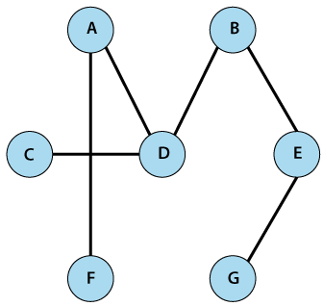

3. Define the following terms: state space, explicit constraints, implicit constraints, problem state, solution states, answer states, live node, E-node, dead node, bounding functions.

4. Write the backtracking algorithm for solving N-Queens problem with state space tree.

5. Give the statement of sum of subsets problem. Find all sum of subsets for n=4, (w1, w2, w3, w4) = (3, 4, 5, 6) and M=13. Draw the portion of the state space tree using fixed – tuple sized approach.